**Practical No : 07**

**Aim : Write a Java program to demonstrate the connections to MongoDB**

**Q1) Insert**

**Code :**

import com.mongodb.client.MongoCollection;

import com.mongodb.client.MongoDatabase;

import com.mongodb.MongoClient;

import org.bson.Document;

public class insert

{

public static void main(String args[])

{

MongoClient mongo=new MongoClient("localhost",27017);

System.out.println("connected to the database successfully:");

MongoDatabase database=mongo.getDatabase("TYCS_248624");

MongoCollection<Document>collection=database.getCollection("SANGRAM");

System.out.println("Collection SANGRAM selected successfully");

Document document=new Document();

document.append("ID",1);

document.append("Rollno",248624);

document.append("age",21);

document.append("college","Mulund College of Commerce");

collection.insertOne(document);

System.out.println("Document inserted Successfully");

}

}

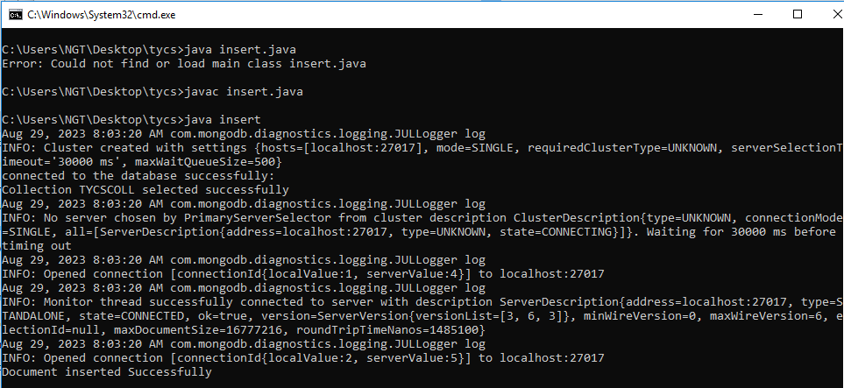**Output :**

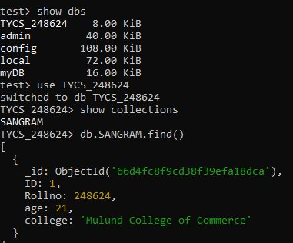

**Q2) Retrieve**

**Code :**

import com.mongodb.client.MongoCollection;

import com.mongodb.client.FindIterable;

import com.mongodb.client.MongoDatabase;

import com.mongodb.MongoClient;

import org.bson.Document;

import java.util.Iterator;

public class retrieve {

public static void main(String args[]) {

MongoClient mongo = new MongoClient("localhost", 27017);

System.out.println("Connected to the database successfully:");

MongoDatabase database = mongo.getDatabase("TYCS_248624");

MongoCollection<Document> collection = database.getCollection("SANGRAM ");

System.out.println("Collection SANGRAM selected successfully");

FindIterable<Document> iterDoc = collection.find();

Iterator it = iterDoc.iterator();

while (it.hasNext()) {

System.out.println(it.next());

}

mongo.close();

}

}

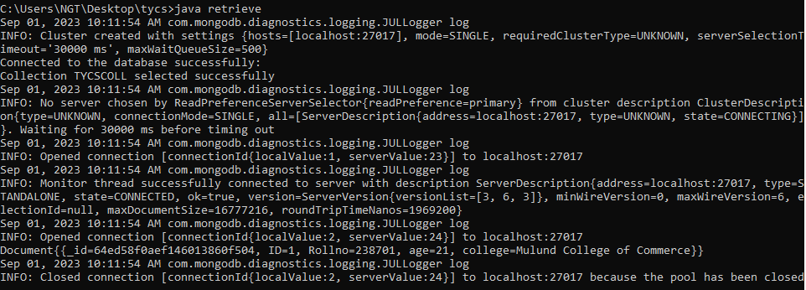**Output :**

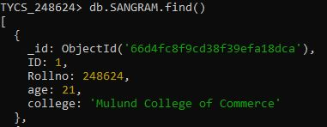

**Q3) Update**

**Code :**

import com.mongodb.client.MongoCollection;

import com.mongodb.client.MongoDatabase;

import com.mongodb.MongoClient;

import org.bson.Document;

import com.mongodb.client.model.*;

public class Update {

public static void main(String[] args) {

MongoClient mongo = new MongoClient("localhost", 27017);

System.out.println("Connected to the database successfully:");

MongoDatabase database = mongo.getDatabase("TYCS_248624");

MongoCollection<Document> collection = database.getCollection("SANGRAM ");

System.out.println("Collection SANGRAM selected successfully");

Document filter = new Document("Rollno", 248624);

Document updateDoc = new Document("$set", new Document("age", 22));

collection.updateOne(filter, updateDoc);

System.out.println("Document updated Successfully");

}

}

**Output :**

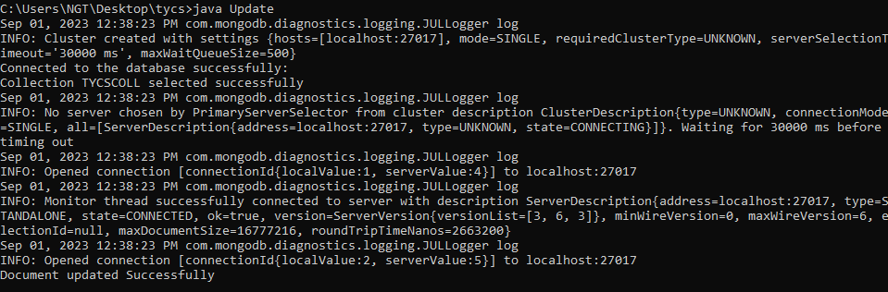

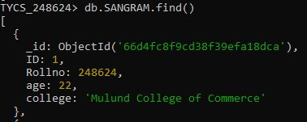

**Q4) Delete**

**Code :**

import com.mongodb.client.MongoCollection;

import com.mongodb.client.MongoDatabase;

import com.mongodb.MongoClient;

import org.bson.Document;

import com.mongodb.client.model.Filters;

public class Delete {

public static void main(String[] args) {

MongoClient mongo = new MongoClient("localhost", 27017);

System.out.println("Connected to the database successfully:");

MongoDatabase database = mongo.getDatabase("TYCS_248624");

MongoCollection<Document> collection = database.getCollection("SANGRAM ");

System.out.println("Collection SANGRAM selected successfully");

Document filter = new Document("Rollno", 248624);

collection.deleteOne(filter);

System.out.println("Document deleted Successfully");

}

}

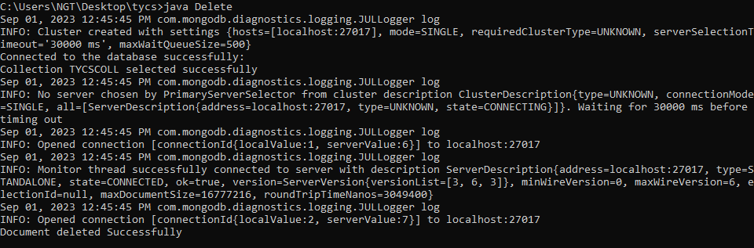**Output :**

